1. 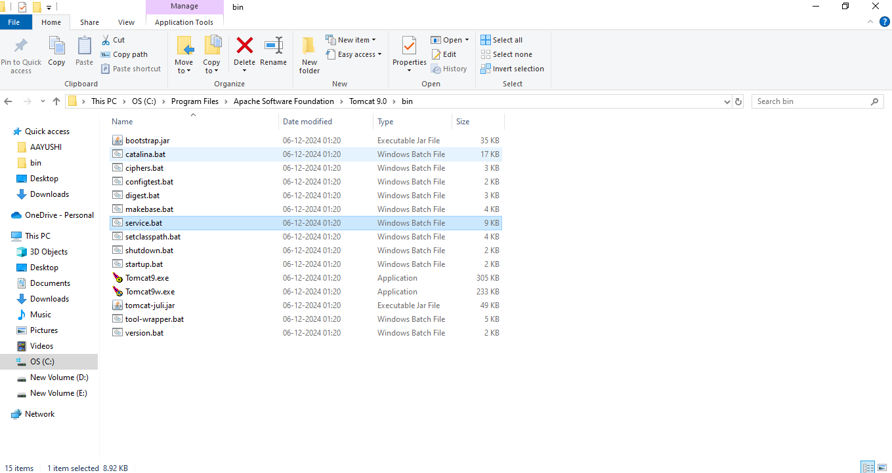Goto this locations and click -> tomcat.exe (C:\Program Files\Apache Software Foundation\Tomcat 9.0\bin)



1. Open chrome and write -> <http://localhost:8080/khushant/index.jsp>

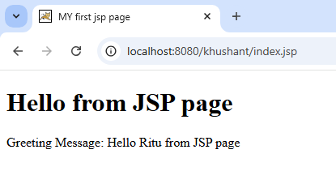



Folder name stored in

Webapps -> khushant -> Index.jsp

File name .jsp



1. 